Things I need help with

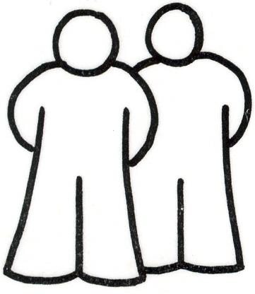

I need 2 people to wash, dress and toilet me

I need help to tell you things.
(see ‘How I communicate’ page)

In fact, I need help with most things, but I would like you to encourage me to:

- make choices
- keep good body position – head and arms
- cooperate with carers
- ask for food and drink when I’m hungry or thirsty

